
RAJALAKSHMI INSTITUTE OF TECHNOLOGY
(An Autonomous Institution, Affiliated to Anna University, Chennai)

DEPARTMENT OF ARTIFICIAL INTELLIGENCE AND DATA SCIENCE
ACADEMIC YEAR 2025 - 2026
SEMESTER IV
AL23421 - MACHINE LEARNING LABORATORY
MINI PROJECT REPORT

REGISTER NUMBER | 2117240070248
NAME | RAKSHANA PRAKASH
PROJECT TITLE | Forecast monthly car sales using Linear Regression – Kaggle Car Sales
DATE OF SUBMISSION
FACULTY IN-CHARGE | Mrs. T. Subashini

Signature of Faculty In-charge Signature of HoD

INTRODUCTION
The automotive industry is one of the most significant contributors to the global economy, with car sales serving as a key indicator of economic growth, consumer demand, and market stability. Over time, car sales data accumulates in large volumes, forming time-dependent datasets that reflect patterns such as seasonality, growth trends, and fluctuations due to external factors. Analyzing and forecasting such data is essential for manufacturers, dealers, and policymakers to optimize production, manage inventory, and design effective marketing strategies.
However, due to the presence of variations caused by economic cycles, promotions, seasonal demand, and consumer behavior, manually analyzing this data becomes inefficient and often inaccurate. Traditional statistical approaches may fail to capture underlying patterns effectively when dealing with large datasets.
Machine Learning techniques provide a structured and efficient way to analyze such data. Among these, Linear Regression is one of the simplest yet powerful supervised learning algorithms used for prediction tasks. It establishes a linear relationship between independent and dependent variables, making it suitable for identifying trends in time-series data.
In this project, Linear Regression is applied to forecast monthly car sales using a publicly available Kaggle dataset. The study involves preprocessing the data, visualizing patterns, building a regression model, and predicting future sales values. The aim is to demonstrate how analytical techniques can transform raw sales data into meaningful insights, enabling better decision-making and planning.

PROBLEM STATEMENT
Car sales data exhibits variability over time due to seasonal demand, economic changes, and market conditions. Traditional analysis methods fail to accurately predict future sales trends. Therefore, there is a need to develop a predictive model using Linear Regression to analyze historical data and forecast future monthly car sales.

GOAL
The primary goal of this project is to develop a predictive model for forecasting monthly car sales using Linear Regression. The objectives include:
- Understanding and analyzing historical car sales data
- Identifying trends and patterns over time
- Building a Linear Regression model for prediction
- Evaluating model performance using statistical metrics
- Forecasting future monthly car sales
- Visualizing actual and predicted results for better interpretation

THEORETICAL BACKGROUND
The process of forecasting monthly car sales involves understanding the underlying statistical and mathematical principles that govern predictive modeling. In this project, Linear Regression is used as the primary technique due to its simplicity, interpretability, and effectiveness in modeling linear relationships in time-series data. This section provides a comprehensive overview of the theoretical concepts associated with Linear Regression and its application in forecasting.
1. Overview of Time Series Data
Time series data refers to a sequence of data points collected at regular intervals over time. In the context of car sales, the dataset consists of monthly observations, where each data point represents the number of cars sold in a specific month.
Time series data typically exhibits the following components:
- Trend: The long-term movement in the data (increasing or decreasing sales over time)
- Seasonality: Regular and repeating patterns observed over fixed intervals (e.g., higher sales during festive seasons)
- Cyclic Patterns: Long-term fluctuations influenced by economic cycles
- Irregular Components: Random variations or noise
Understanding these components is essential before applying any predictive model, as they influence the accuracy and reliability of forecasts.
2. Linear Regression Model
Linear Regression is a statistical method used to establish a relationship between a dependent variable and one or more independent variables. In this project, the dependent variable is monthly car sales, and the independent variable is time (represented as a numerical index).
Interpretation of Parameters:
- Intercept ($β_{0}$): Represents the expected value of sales when time is zero
- Slope ($β_{1}$): Indicates the rate of change in sales with respect to time
- Error Term ($ϵ$): Represents the difference between actual and predicted values
The goal of Linear Regression is to determine the optimal values of $β_{0}$and $β_{1}$such that the prediction error is minimized
3. Ordinary Least Squares (OLS) Method
The most common approach to estimate the parameters of a linear regression model is the Ordinary Least Squares (OLS) method. This method minimizes the sum of squared differences between the actual and predicted values.
$$min⁡\sum_{i=1}^{n}{(}y_{i}-{\hat{y}}_{i})^{2}$$
Where:
- $y_{i}$= Actual value
- ${\hat{y}}_{i}$= Predicted value
By minimizing this function, the model ensures that the predicted line is as close as possible to the actual data points.
4. Assumptions of Linear Regression
For Linear Regression to produce reliable results, certain assumptions must be satisfied:
a) Linearity
The relationship between independent and dependent variables must be linear. In this case, car sales should follow a linear trend over time.
b) Independence of Errors
The residuals (errors) should not be correlated with each other.
c) Homoscedasticity
The variance of errors should remain constant across all levels of the independent variable.
d) Normality of Errors
The residuals should follow a normal distribution for accurate statistical inference.
Violation of these assumptions may lead to biased or inaccurate predictions.
5. Feature Engineering for Time Series
Since Linear Regression requires numerical input, time-based features must be transformed appropriately. Common techniques include:
- Converting dates into time index values
- Extracting features such as month, year, or season
- Creating lag variables (previous month sales)
In this project, a simple time index is used to represent the progression of months.

6. Model Evaluation Metrics
Evaluating the performance of the model is crucial to determine its effectiveness. The following metrics are commonly used:
a) Mean Absolute Error (MAE)
Measures the average absolute difference between actual and predicted values.
b) Mean Squared Error (MSE)
Penalizes larger errors more significantly by squaring them.
$$MSE=\frac{1}{n}∑(y-\hat{y})^{2}$$
c) R² Score (Coefficient of Determination)
Represents the proportion of variance in the dependent variable explained by the model.
$$R^{2}=1-fracSS_{res}SS_{tot}$$
A higher R² value indicates better model performance.

7. Limitations of Linear Regression in Time Series
Although Linear Regression is simple and effective, it has certain limitations when applied to time series data:
- Cannot capture non-linear patterns
- Does not handle seasonality automatically
- Sensitive to outliers
- Assumes a constant trend over time
Algorithm | Advantage | Limitation
Linear Regression | Simple, fast, interpretable | Cannot capture non-linearity
ARIMA | Handles time dependencies | Complex to tune
LSTM | Captures long-term patterns | Requires large data
Polynomial Regression | Handles non-linearity | Risk of overfitting
8. Comparison with Other Algorithm

9. Justification for Using Linear Regression
Despite its limitations, Linear Regression is chosen for this project because:
- It provides a clear understanding of trend behavior
- It is computationally efficient
- It works well for datasets with linear characteristics
- It serves as a strong baseline model for comparison with advanced techniques

ALGORITHM EXPLANATION WITH EXAMPLE
Steps of the Algorithm
- Import required libraries
- Load the dataset
- Convert date column into numerical format (time index)
- Split dataset into input (X) and output (y)
- Train Linear Regression model
- Predict values using trained model
- Evaluate model performance
- Visualize results

Example
Consider the following sample data:
Month | Sales
Jan | 200
Feb | 220
Mar | 250
Apr | 270
The model identifies an increasing trend and predicts future sales accordingly. For example, it may predict May sales as approximately 290 based on the trend
IMPLEMENTATION CODE AND DATASET USED
 | Category |  | Description / Example
 | Dataset Name |  | Monthly Car Sales Dataset
 | Domain |  | Automotive / Business
 | Objective |  | Regression
 | Data Source |  | Public (Kaggle)
 | Number of Samples |  | Approximately 100–200
 | Data Type |  | Tabular
 | Instance Description |  | Each row represents monthly sales
Features (Inputs) |  | Month, Time Index
 | Feature Types |  | Numerical
 | Target Variable |  | Sales
 | Number of Classes |  | Not applicable
 | License |  | Open/Public dataset
 | Version |  | Latest
Python code
# Forecast Monthly Car Sales using Linear Regression

import pandas as pd
import numpy as np
import matplotlib.pyplot as plt
from sklearn.linear_model import LinearRegression
from sklearn.metrics import mean_squared_error, r2_score

# -----------------------------
# Step 1: Load Dataset
# -----------------------------
df = pd.read_csv("car_sales.csv")

# Convert Month column to datetime
df['Month'] = pd.to_datetime(df['Month'])

# Sort values
df = df.sort_values('Month')

# -----------------------------
# Step 2: Feature Engineering
# -----------------------------
df['Time_Index'] = np.arange(len(df))

X = df[['Time_Index']]
y = df['Sales']

# -----------------------------
# Step 3: Train-Test Split
# -----------------------------
split = int(len(df) * 0.8)

X_train = X[:split]
X_test = X[split:]
y_train = y[:split]
y_test = y[split:]

# -----------------------------
# Step 4: Train Model
# -----------------------------
model = LinearRegression()
model.fit(X_train, y_train)

# -----------------------------
# Step 5: Predictions
# -----------------------------
y_pred = model.predict(X_test)

# -----------------------------
# Step 6: Evaluation
# -----------------------------
mse = mean_squared_error(y_test, y_pred)
print("Mean Squared Error:", mse)

print("R2 Score:", r2_score(y_test, y_pred))
print("Slope:", model.coef_[0])
print("Intercept:", model.intercept_)

# -----------------------------
# Step 7: Future Forecast
# -----------------------------
future_months = 12
last_index = df['Time_Index'].iloc[-1]

future_index = np.arange(last_index + 1, last_index + future_months + 1)

# Fix: use DataFrame (avoids warning)
future_index_df = pd.DataFrame(future_index, columns=['Time_Index'])

future_predictions = model.predict(future_index_df)

# Fix: use 'ME' instead of 'M'
future_dates = pd.date_range(
start=df['Month'].iloc[-1],
periods=future_months + 1,
freq='ME'
)[1:]
# Step 8: Forecast Table
forecast_df = pd.DataFrame({
"Month": future_dates,
"Predicted Sales": future_predictions
})

print("\nFuture Forecast:")
print(forecast_df)

# Step 9: Visualization
plt.figure(figsize=(10,5))

# Actual
plt.plot(df['Month'], df['Sales'], label="Actual Sales")

# Predicted
plt.plot(df['Month'][split:], y_pred, label="Predicted Sales")

# Future
plt.plot(future_dates, future_predictions, label="Future Forecast")
plt.xlabel("Month")
plt.ylabel("Car Sales")
plt.title("Monthly Car Sales Forecast using Linear Regression")
plt.legend()
plt.show()

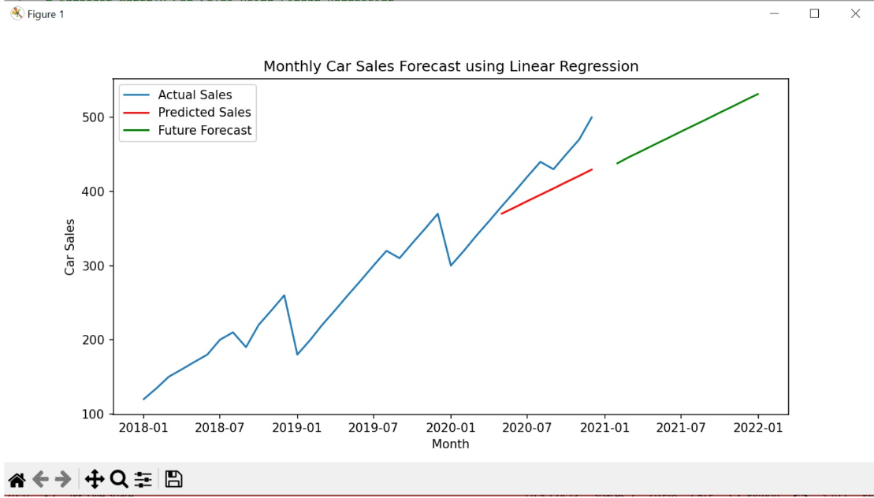
OUTPUT

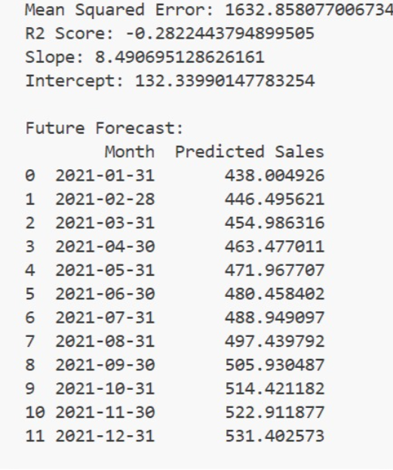

The output of the project includes:
- Graph showing actual vs predicted sales
- Trend line representing growth or decline
- Forecasted values for future months
Observations
- The model captures the overall trend effectively
- Predictions follow a linear pattern
- Minor deviations may occur due to noise

RESULTS AND FUTURE ENHANCEMENT
Results
- Linear Regression successfully modeled the relationship between time and sales
- The model provided accurate predictions for linear trends
- Visualization helped in understanding sales patterns clearly
Future Enhancements
- Use Polynomial Regression for nonlinear data
- Apply ARIMA for time-series forecasting
- Implement LSTM for deep learning-based prediction
- Include additional features like economic indicators
- Develop a real-time prediction dashboard

Git Hub Link of the project along with the report

REFERENCES
1. James, G., Witten, D., Hastie, T., & Tibshirani, R. (2013).
An Introduction to Statistical Learning with Applications in R. Springer.
2. Montgomery, D. C., Peck, E. A., & Vining, G. G. (2012).
Introduction to Linear Regression Analysis. Wiley.
3. Hyndman, R. J., & Athanasopoulos, G. (2018).
Forecasting: Principles and Practice. OTexts.
4. Pedregosa, F., et al. (2011).
Scikit-learn: Machine Learning in Python. Journal of Machine Learning Research.
5. McKinney, W. (2010).
Data Structures for Statistical Computing in Python. SciPy Conference.
6. Kaggle Dataset
Car Sales Dataset.
Available at: https://www.kaggle.com
7. Scikit-learn Documentation
Available at: https://scikit-learn.org
8. Pandas Documentation
Available at: https://pandas.pydata.org

